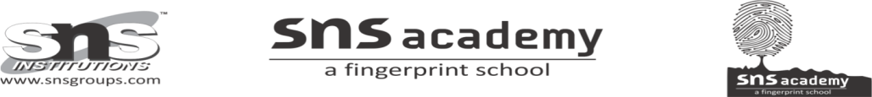
CLASS: LKG
SUBJECT: ENVIRONMENTAL SCIENCE
- MYSELF
(Learning through activity: A box with a mirror pasted inside. Now, Children are allowed to seated in semicircle and the box was passed to each child to open the box and peek into it to see the ‘special person’. Once the children have looked into the box, they find out that the special person is ‘himself/herself’.

